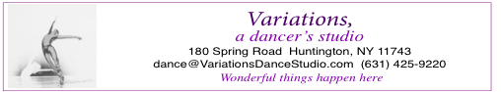 Dance Registration

Student Name: Date of Birth:

Address:

Parents Name(s):

E-mail address: (please write clearly)

Phone (home and cell):

How do you prefer to be contacted? Text ?_____ Email ? ______

Allergies if any

(or any other things you should tell us)

Medical, Image Waiver, and Liability Release

A. I understand that by taking part in this or any dance class and/or performance, there is a possibility of injury or sickness to my daughter/son; therefore, I give my permission for my daughter/son to participate in the dance class and/or performance at/with Variations, a dancer's studio, and do hereby grant permission to hospital staff members to administer immediate treatment to my child should she/he be injured.

B. I give permission to Variations, a dancer's studio, to use images of myself and my child to promote their programs and activities.

C. I also agree to hold harmless the owners of 180 Spring Road, Huntington, NY, Variations, a dancer's studio, and its officers, agents and employees from and against any and all loss, cost, damage, injury, claims or cause of actions of every nature whatsover incurred as a result of my or my child's participation in the dance class or camp or any related activity. I understand

that tuition is non-refundable.

**Signature of Parent or Guardian____________________ Date ______**